Winter sports enthusiasts will be thrilled - the SkiWelt Hopfgarten-Itter is investing € 24 million in a new gondola, in a technical center for snowmaking, snow machines, workshop and reservoir lake

Wow! So much quality. The quality offensive in the SkiWelt Hopfgarten-Itter continues.

The Salvista gondola was built in Itter in 1986 - the first two years as a chair lift, and in 1989 a 4-seater gondola lift to the Kraftalm was finally built. In winter 2019/20 this lift will be in operation for the last season and in 2020/21 you will be able to access the Kleine Salve with an ultra-modern 10-seater gondola. The valley station of the new cable car is in the same place as the old station, the route to Kraftalm will also be the same. A middle station with boarding and alighting will be built at the Kraftalm, the new lift will be a total of 650 m longer.
In the building of the valley station, the complete infrastructure with sports shop, ski rental and ski depot will be completely renewed. The new Salvista gondola will start operating in time for the 2020/21 winter season.
The attractiveness of the new lift will be increased enormously by the extension of the lift, the creation of new slopes and also by the continuous summer operation in the future.

The facts about the new 10 MGD Salvista gondola Itter:
Lift type: 10-person gondola with Ferrari-red panorama gondolas
Speed: 6 m/sec
Capacity: 2100 Pers./h
Length: 2843 m
Duration: 10 min
Special feature: entrance and exit at Kraftalm
Manufacturer: Doppelmayr
Architect/Planning: Seilbahnbüro Gröbner
Start of construction: August 2019
Completion: start of the winter season 2020/21

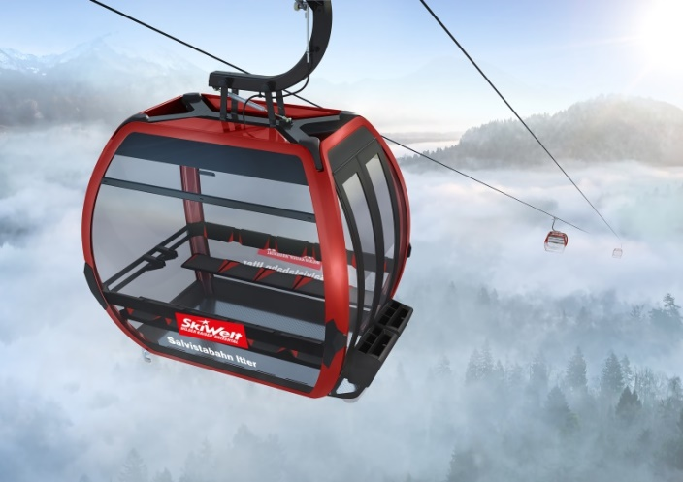
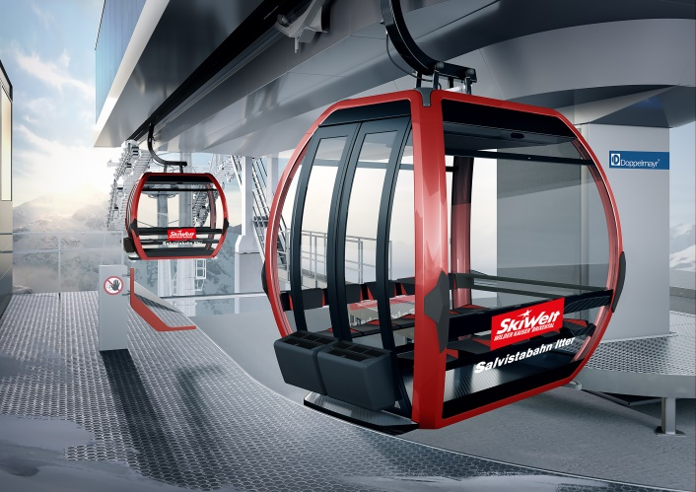

On the Kleine Salve - just below the mountain station of the new Salvista gondola -
a new reservoir lake is built

With a capacity of 50,000 m³, the new lake will contribute significantly to the effectiveness of the Hopfgarten-Itter snowmaking system. The entire implementation takes place according to the latest ecological standards and was worked out and planned in advance with experts.
Start of construction: 2019
Completion: 2020

At the foot of the reservoir lake, a state-of-the-art technology center for the maintenance and garage of the snow groomers and the snow-making system are being built.
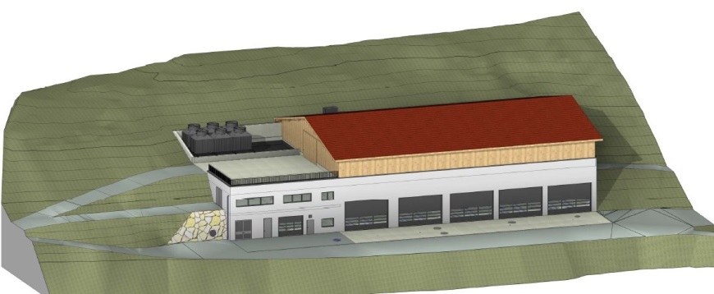

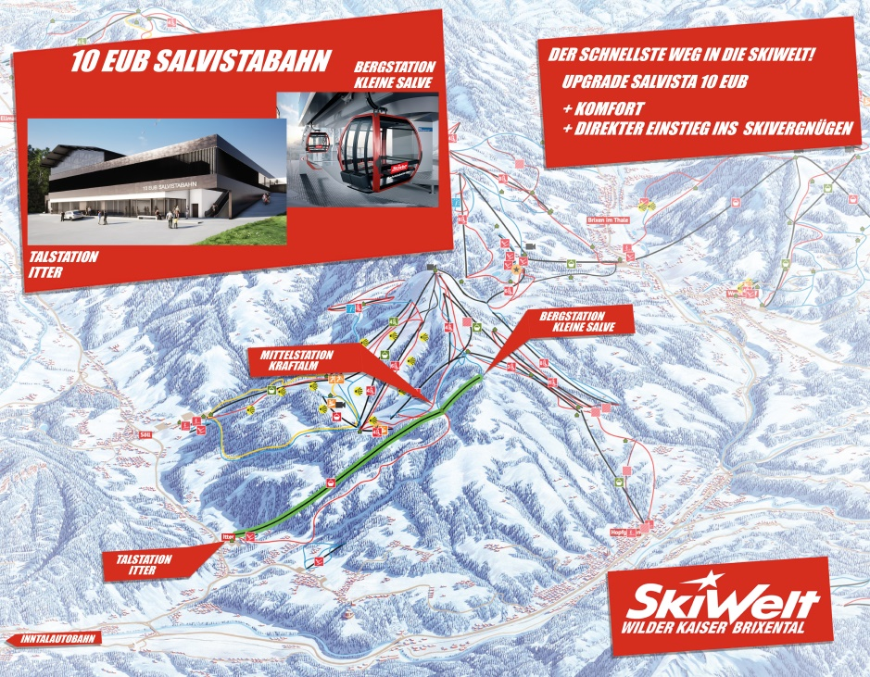

With 90 cable cars and lifts, 284 kilometres of slopes for all ability levels – almost all of them with state-of-the-art snowmaking equipment (of the 229 kilometres of slopes with snowmaking, 120 kilometres can be made fit for skiing in just 3 days) – and 81 cosy Alpine huts, SkiWelt Wilder Kaiser – Brixental is one of the largest and most modern ski resorts in the world.

INFORMATION lift operator Hohe Salve Hopfgarten-Itter-Kelchsau GmbH & Co KG
bergbahnen.hopfgarten@skiwelt.at, Tel: +43 5335 2238
QUERIES: F. Eberl (f.eberl@skiwelt.at), Tel: +43 664 3938554

